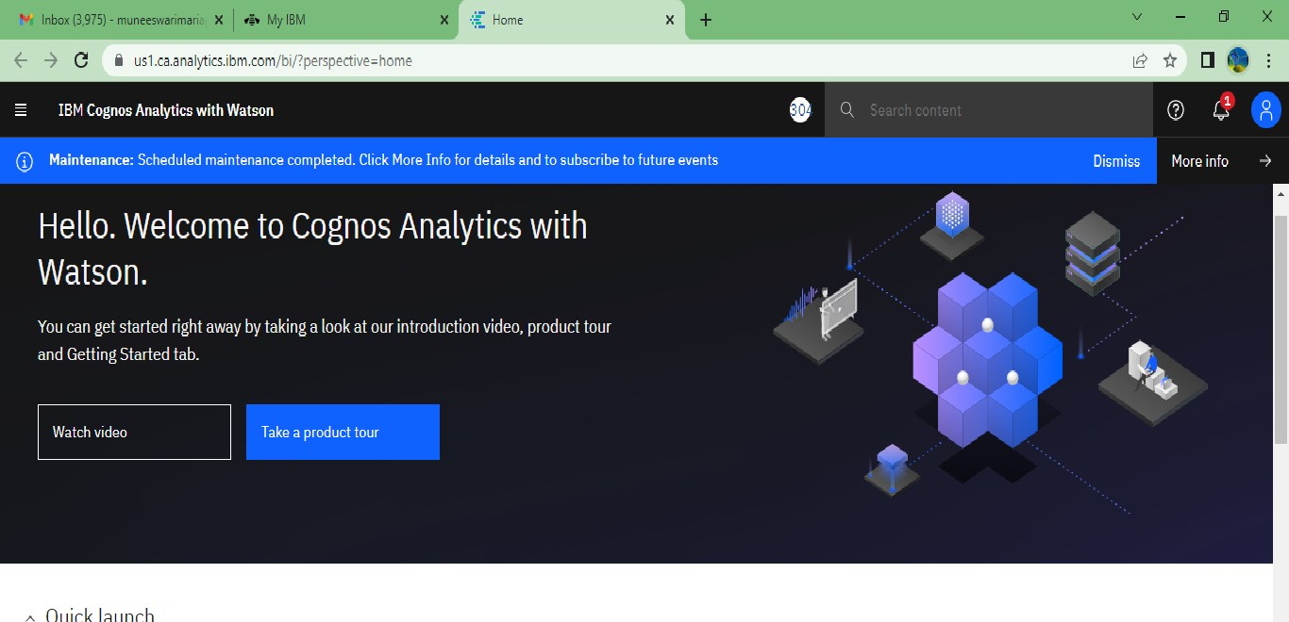

Quick

launch

oo

|  |  |  |  |
| --- | --- | --- | --- |
| Upload data | Prepare data | Exploration | Present data |
| Upload or drag and drop | use data modules to clean | Quickly find unbiased | Create sophisticated, |

